FREE family arty crafts for half-term

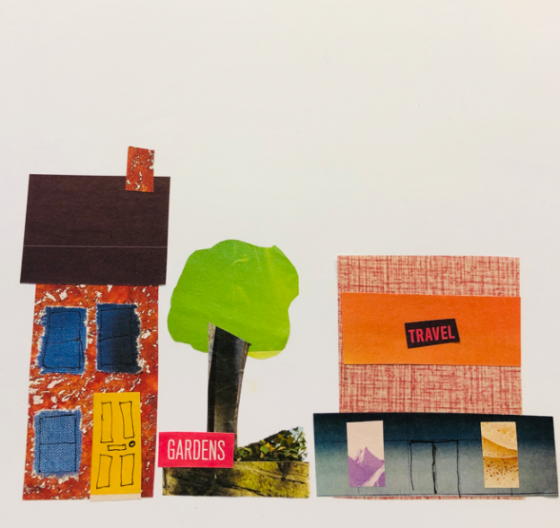
Build up Bootle
Make a Bootle building for our street

Tuesday 18 February 10am-12noon

The Bootle Hive
Opposite Coffee House
The Strand Shopping Centre

Just drop in!

